|  |  |  |  |  |  |
| --- | --- | --- | --- | --- | --- |
| Name: | Roman Kovtun | DSI#: | D40685801 | Date: | March 27, 2019 |

**Web375 Week 4 Lab Report—Configuring an SFTP Server**

**Lab 4 Grading Rubric**

|  |  |
| --- | --- |
| **Category** | **Points** |
| Task C: Step 1: tail of passwd | 5 |
| Task C: Step 2: vsftpd status | 5 |
| Task C: Step 3: contains of hello01 on PLABFED02 | 10 |
| Task C: Step 4: first ftp attempt as yourFirstName | 10 |
| Task C: Step 5: first ftp attempt as anonymous | 10 |
| Task C: Step 7: second ftp attempt as anonymous | 10 |
| Task C: Step 9: second ftp attempt as yourFirstName | 10 |
| Total | 60 |

**Task C: Step 1**

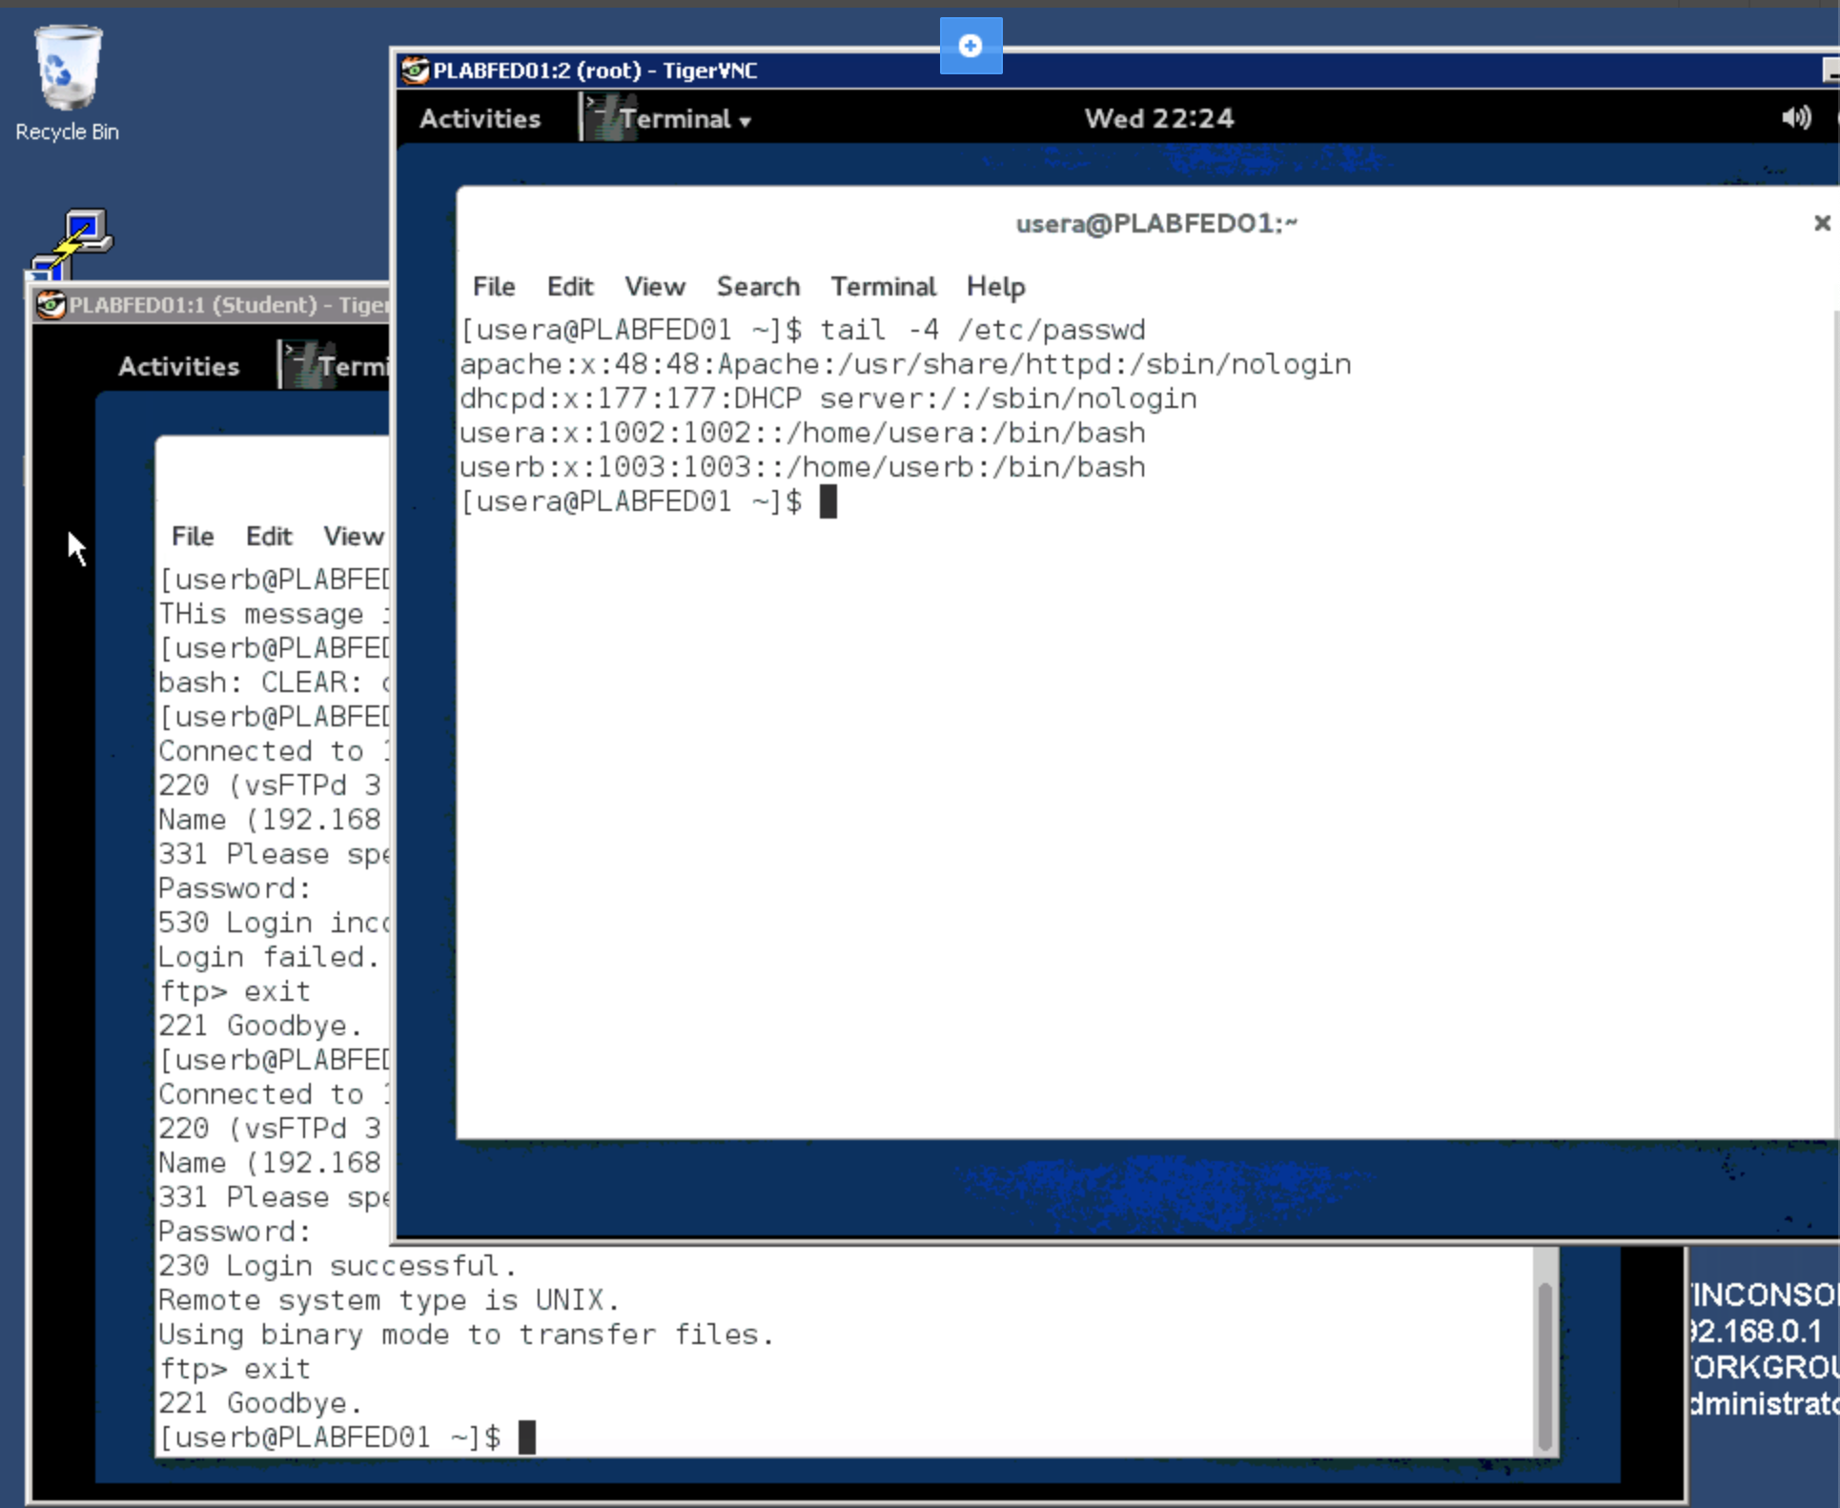

**Task C: Step 2**

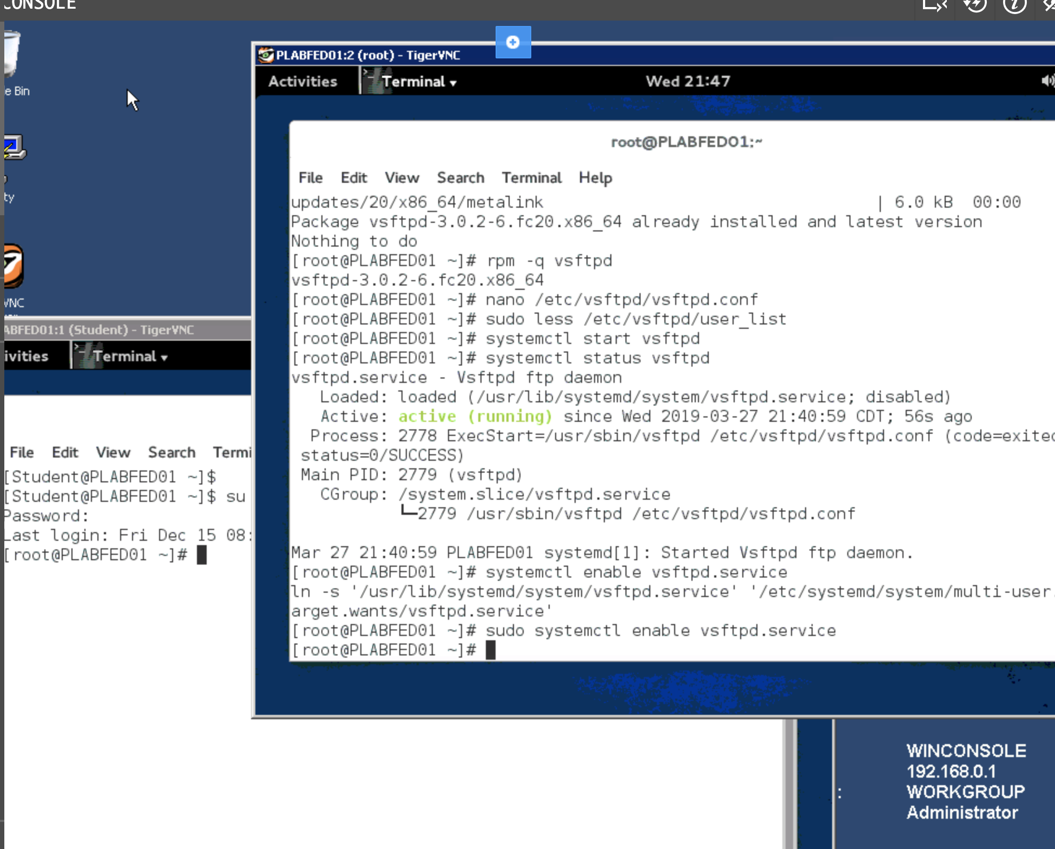

**Task C: Step 3**

USER A

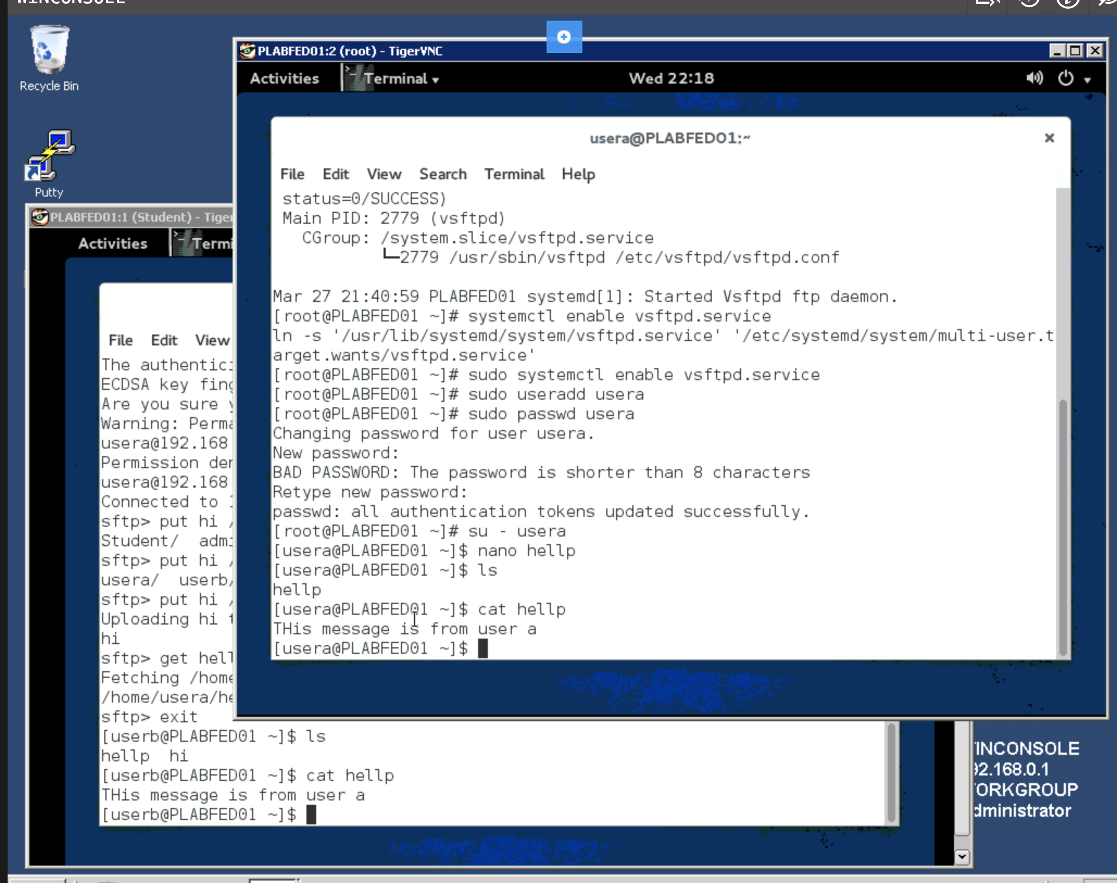

USER B

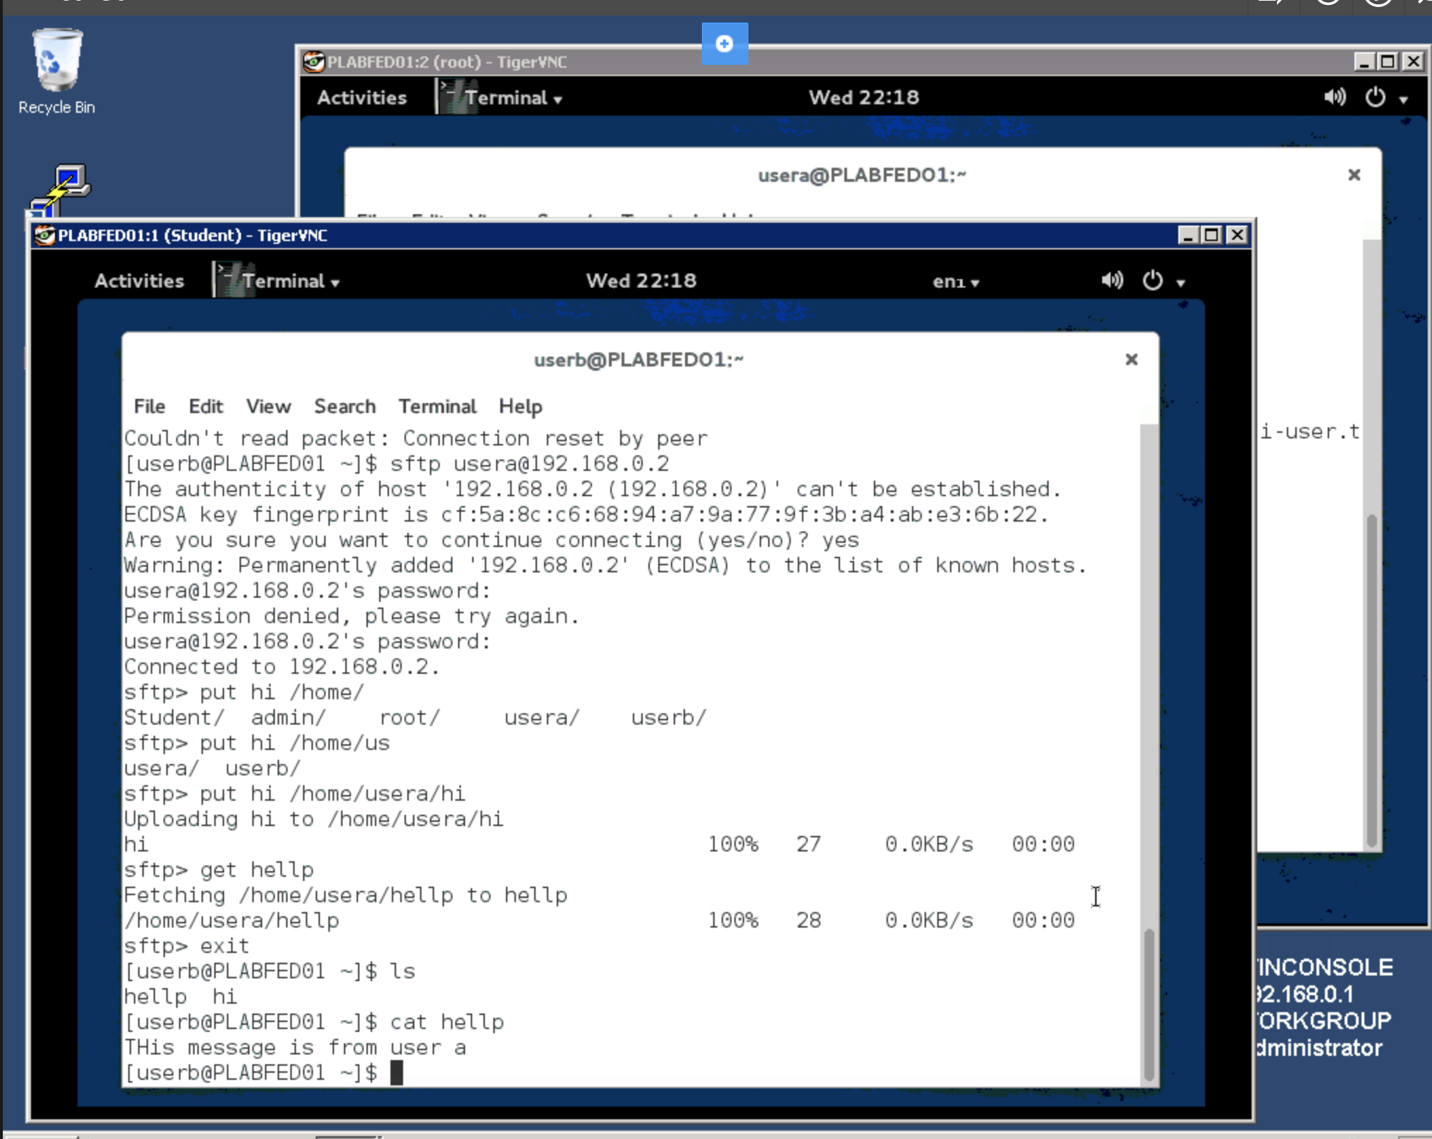

**Task C: Step 4**

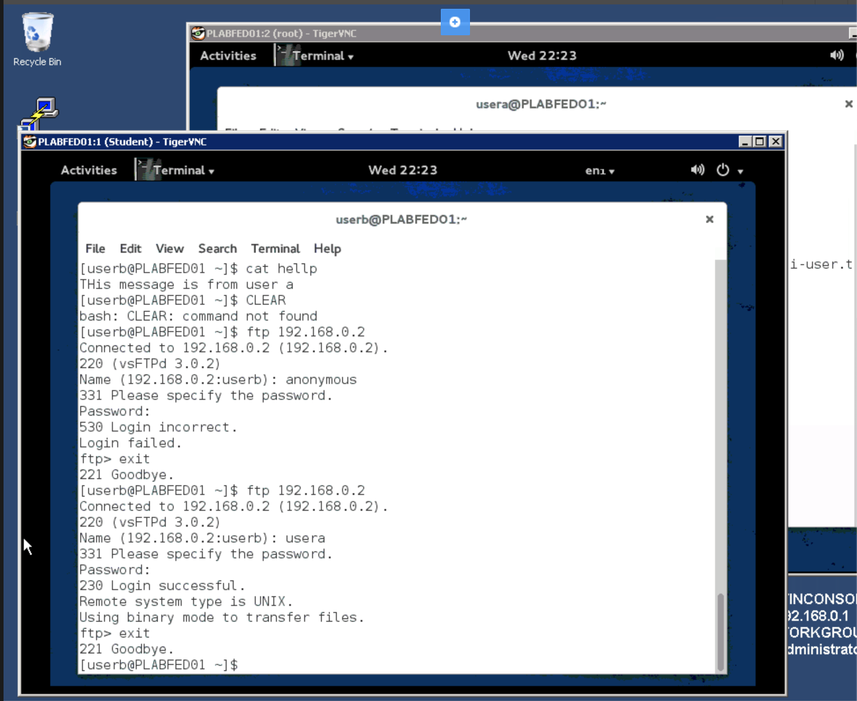

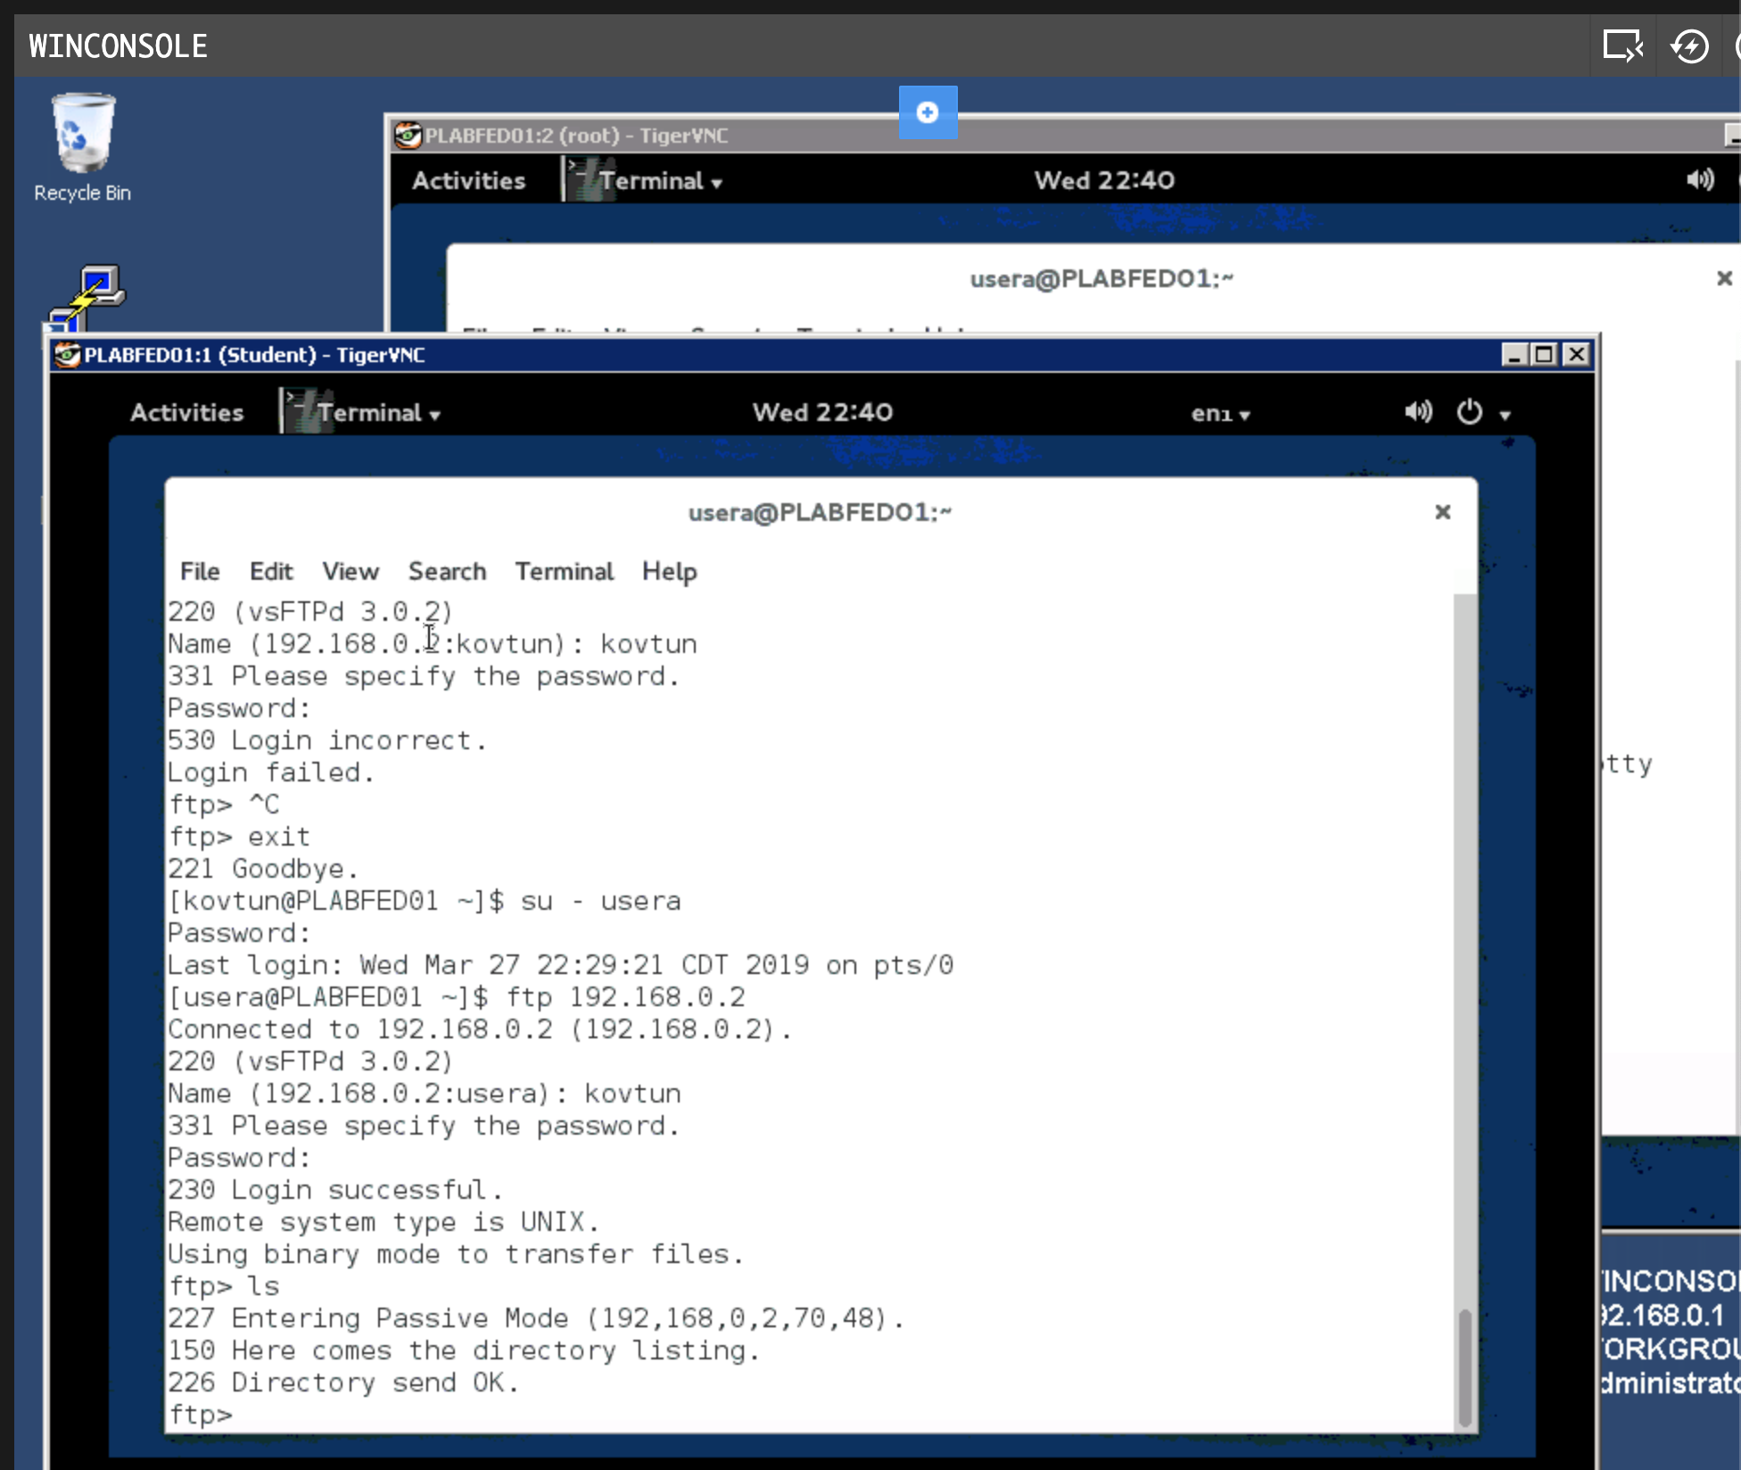

**Task C: Step 5**

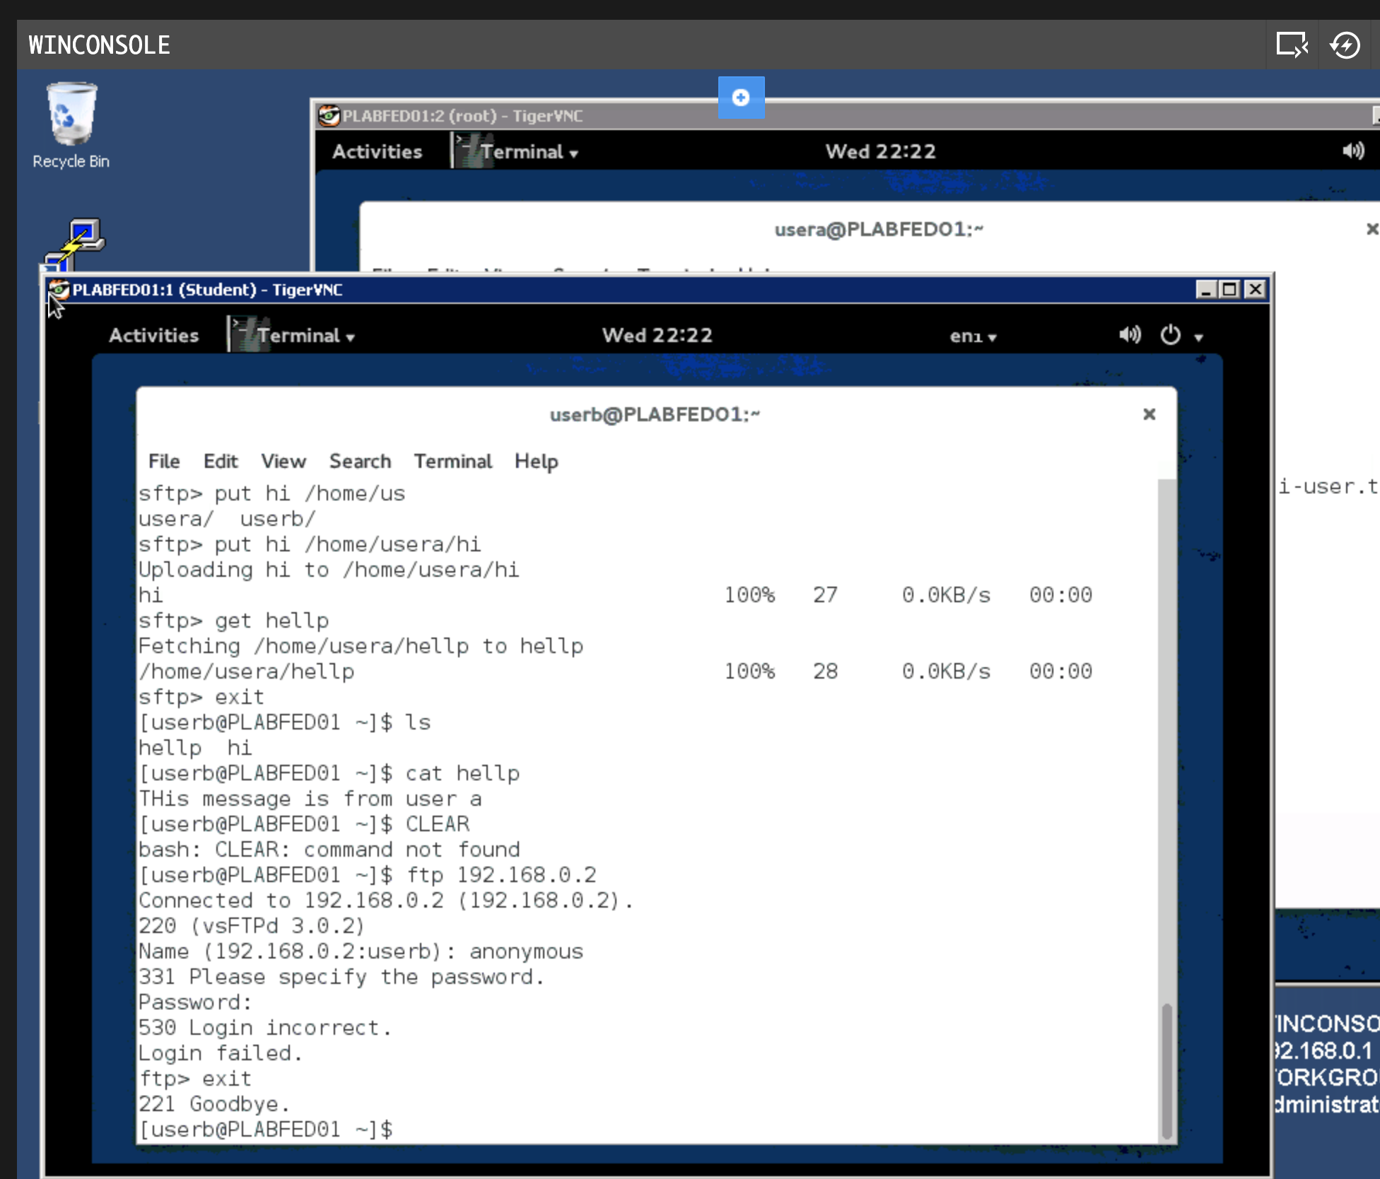

**Task C: Step 7**

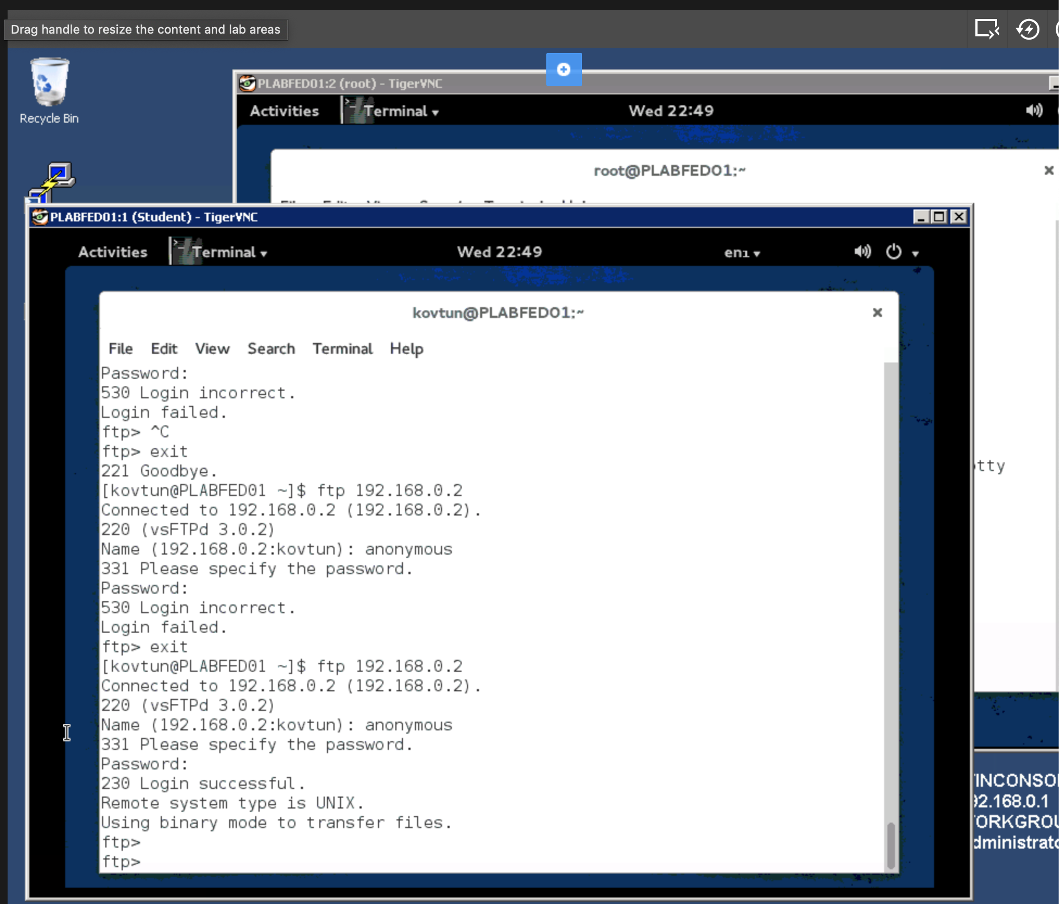

**Task C: Step 9**

